Practical 6

SQL queries to implements various aggregate function on table data using Group by, order by and having clauses.

**Write SQL query to create a table author_2021**.

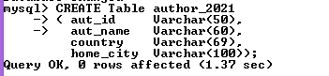

**Write SQL query to insert data in to the author_2021 table.**

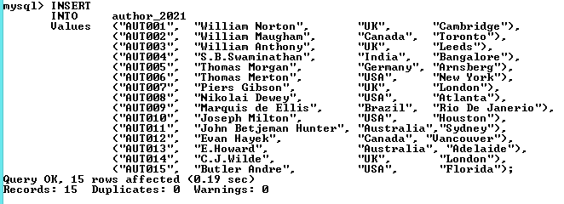

**Write SQL query to retrieve the data from author_2021 table.**

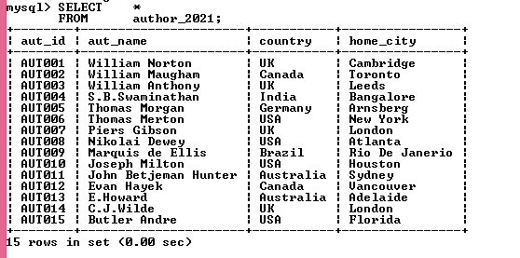

**Write SQL query to create book mast 2120 table**

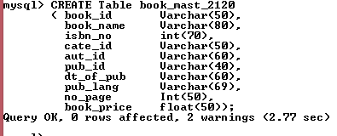

**Write SQL query to insert data in to the book mast 2120 table.**



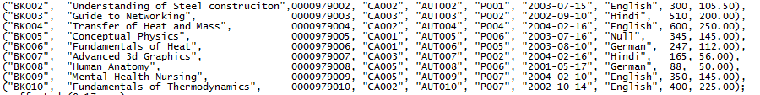

**Write SQL query to retrieve data from the table book mast 2120 table.**

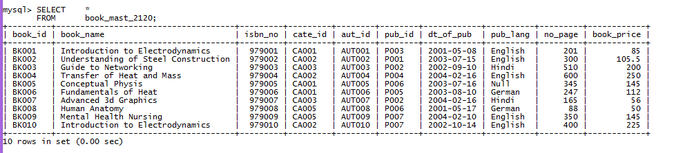

**Write SQL query to create table publisher 2120.**

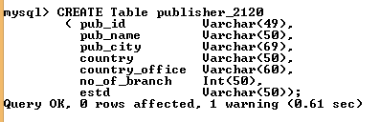

**Write SQL query to insert data in to table using insert command in publisher 2120 table.**

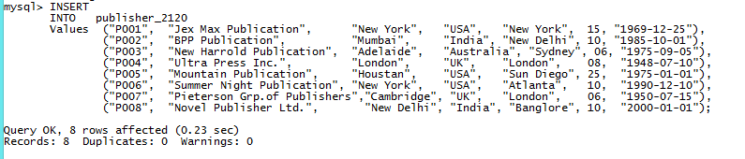

**Write SQL query to retrieve data from the table using SELECT command in publisher_2120 table.**

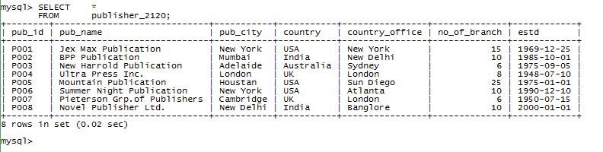

**Write SQL query to create table using CREATE command in purchase_2120 table.**

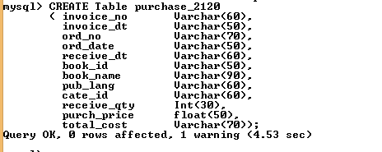

**Write SQL query to insert data using INSERT command in purchase 2120 table.**

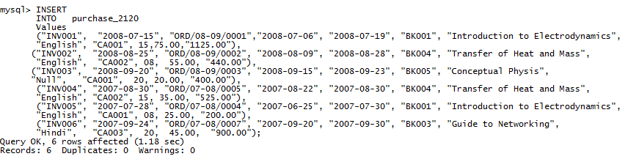

**Write SQL query to retrieve data using SELECT command in purchase 2120 table.**

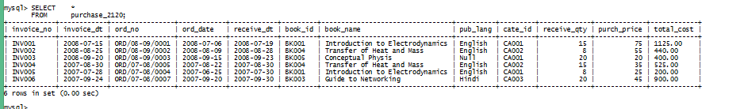

**Query 1 Write SQL query to list out average page number of book master table.**



**Query2. Write SQL query to list out publication ID and average number of books and grouped according to the publication ID.**

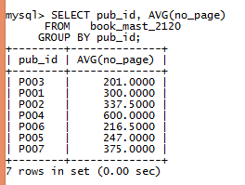

**Query3. Write a SQL queries to list out name of country, publication city of all the publishers which have either country “USA” or “UK” and grouped the result set according to country and publication city**.

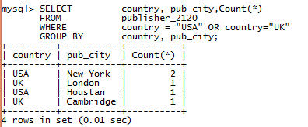

**Query4. Write a SQL query to list out the publication id of books and concatenate the group according to category ID.**

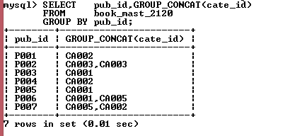

***Query5. Write a SQL query to list out the name of book and price of book which have maximum price among all books.***

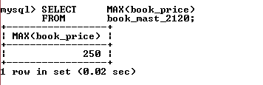

**Query6. Write a SQL query to list out name of book and price of book which have minimum price among all books.**

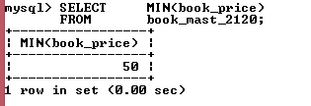

**Query7. Write a SQL query to list out those countries and publisher cities which have the minimum number of branches for each group of country and pub city.**

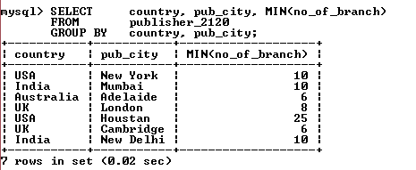

**Query8. Write a SQL query to compute the population standard deviation of the total cost from ‘purchase table**.

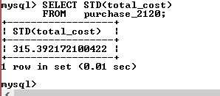

**Query9. Write a SQL query to calculate the sum of multiplication of receive qty and purch price from the purchase table for each group of category.**

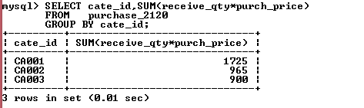

**Query10. Write a SQL query to compute the population standard variance of ‘total_cost’ from purchase table.**

